 | 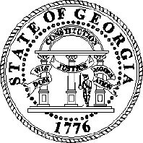
 | The Office of Secretary of State
 | Professional Licensing Board
Brad Raffensperger | 237 Coliseum Drive | Gabriel Sterling
Secretary of State | Macon, GA 31217 | Interim Division Director
AGENDA
Joint Secretary of State
Meeting
July 12, 2022, at 1:00 P.M.

- Call to Order – La Trenda Tyler Jones (representing Gabriel Sterling)
  - Approval of the Agenda
  - Approval of the June 7, 2022, meeting minutes
- Public Hearing
  - Proposed Rule Amendments
    - 295-2-.04 Licenses Expiring December 31 - Odd Years
  - 295-15-.02 Long Term Care Facility Administrators
- Adjournment

