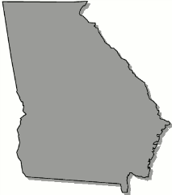
Georgia
B o a r d O f N u r s i n g

December 15, 2022 - Board Meeting Agenda

Thursday, December 15, 2022

4:00pm Open Session

Open Session Conference Call / Zoom Information:
https://sos-ga-gov.zoom.us/j/96161138685?pwd=MjUra3ZkejdkUlVCQTBiZXdYazBFQT09&from=addon

Meeting ID: 961 6113 8685
Passcode: 039300

Executive Session

Case Review
Complaint Files
Application Files
Compliance Files
Investigative Files
AG Memos
Initial Decisions

Attorney General’s Status Report – Kimberly Emm

Open Session

Voting
Cases
AG Memos
Grids
Meeting Minutes
Licenses Administratively Issued

Correspondence

Strategic Planning
Education Committee Appointments and Report
Education Programs – non-compliant with rules
IV Hydration Policy

Rule Waivers

