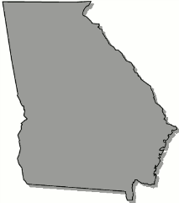
Georgia
B o a r d O f N u r s i n g

April 19, 2023 – APRN Committee Meeting Agenda

Wednesday, April 19, 2023

4:00pm Zoom Meeting

Call to Order

Position Statement - Administration of Propofol, Etomidate, and Neuromuscular Blocking Agents

Position Statement - Family Nurse Practitioners in Acute Care Settings
(No minutes to be reviewed at this meeting)

