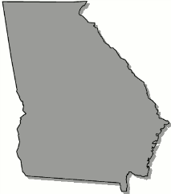
Georgia
B o a r d O f N u r s i n g

April 11, 2023 – Education Committee Meeting Agenda

Tuesday, April 11, 2023

4:00pm Teams Meeting

Call to Order

Review of Minutes from December 5, 2022 Education Committee Meeting

Rule Review:
Rule 410-8-.02
Rule 410-8-.03
Rule 410-8-.05
Rule 410-8-.06
Rule 410-8-.08

