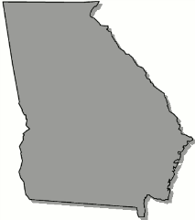
Georgia
B o a r d O f N u r s i n g

February 27, 2024 – School Health Committee Meeting Agenda

Tuesday, February 27, 2024

2:00pm Microsoft Teams Meeting Information:
Join on your computer, mobile app or room device
Click here to join the meeting
Meeting ID: 252 928 192 039
Passcode: q5TF27
Download Teams | Join on the web

Call to Order

Review School Health Policy from Arkansas

Discuss School Health Protocols for RNs and LPNs

