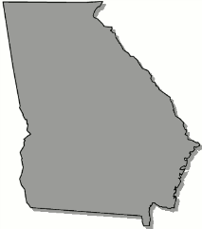
Georgia
B o a r d O f N u r s i n g

School Nursing Committee Meeting Agenda

Tuesday, May 28, 2024

Microsoft Teams Need help? Join the meeting now Meeting ID: 223 074 018 521 Passcode: jyzqYZ Dial in by phone +1 469-552-5803,,500609109# United States, Dallas Find a local number Phone conference ID: 500 609 109#

10:00am Call to Order

Introductions

Committee Chair and Secretary Selection

Committee Mission and Goals

Explore Particulars of Committee: Meeting Schedules, Duration, and Timings

11:00am Adjourn

