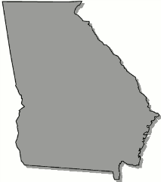
Georgia
B o a r d O f N u r s i n g

APRN Rules Committee Meeting Agenda

Friday, January 24, 2025

2:00 pm Open Session
Join the meeting now
Meeting ID: 285 016 000 08
Passcode: HN2Xa7Tr

Discussion of Rule Amendment Procedure

Committee Objectives

Structure and Organization of Rules

