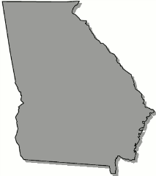
Georgia
B o a r d O f N u r s i n g

APRN Rules Committee Meeting Agenda

Friday, February 7, 2025

3:00 pm Open Session
Join the meeting now
Meeting ID: 279 806 377 021
Passcode: z53RL786

Structure and Organization of Rules

Licensure: Role and Population

Scope of Practice Rules

