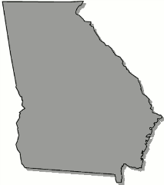
Georgia
B o a r d O f N u r s i n g

June 8, 2026

Emergency Board Meeting Agenda

(This is a virtual meeting.)

Monday, June 8, 2026

4:00 pm Open Session
Microsoft Teams meeting
Join:https://teams.microsoft.com/meet/246167837675258?p=pVjm6SgiDJjcF5JFro
Meeting ID: 246 167 837 675 258
Passcode: rC7NE6Hn

Executive Session

Summary Suspension Review

Open Session

Vote

Adjourn

